Q1)

/home/scs/staff

Q2)

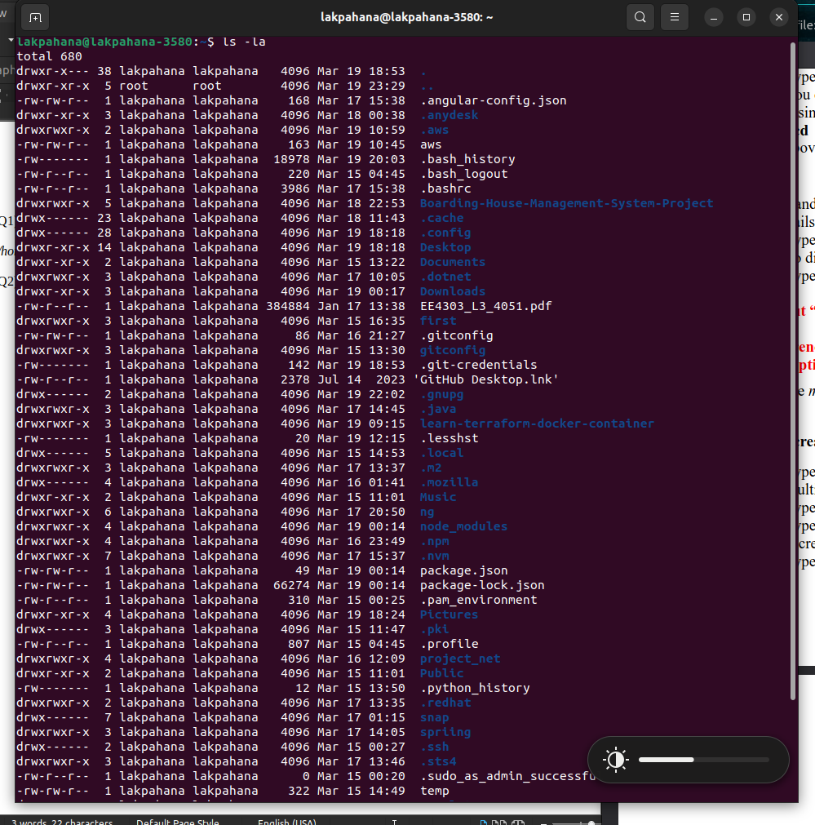
Q5: What difference did you observe between the results of “ls –l” and “ls –la”?
What does the option “-a” mean?

